AIM : Redesign Of Canteen Menu

Procedure :

* Set up your project : Open Figma and create a new project.
* Create a mood board with colors, fonts, and images that you want to use
* Use simple shapes and lines to create a basic layout of your menu. This helps in planning the hierarchy of elements.
* Menu Items: Add the names, descriptions, and prices of the dishes.
* Icons: Use icons to indicate vegetarian, vegan, or spicy dishes
* Link Screens: Connect different screens to demonstrate the navigation and user interactions.
* Test: Test the prototype to ensure everything works smoothly.
* Consistency Check: Ensure all elements are consistent in terms of style and alignment.
* Export: Export the final design in the required format.

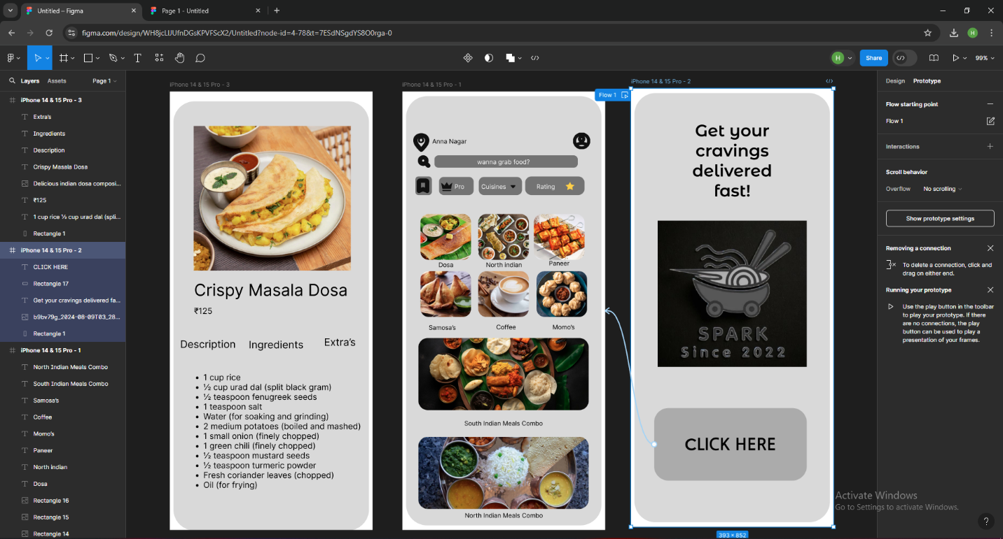

Result : The design is done and the output is verified.